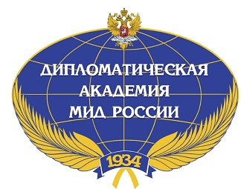
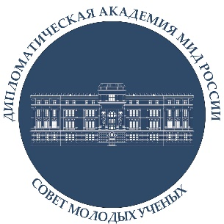

Application form for VIII Annual international scientific conference of young scientists (hybrid format)
“Topical Issues of World Politics from the Perspective of COVID-19”
DECEMBER 2, 2021

Full name:
E-mail:
Tel.:
Place of work or study (full name of the organization, division, position):
Scientific degrees and titles (if applicable):
Panel:
Topic:
Abstract (300-500 symbols, font Times New Roman, size – 14, space – 1.5):
Notes:

For publication in the thesis bulletin, it is necessary to send extended thesis of the reports by October 15th, indicating the relevance of the topic, research problem, research methodology, literature review and conclusions (IMRAD) (not less than 500 words).

